HANDS-ON 8 HTTP Client — API Integration, Observables & Interceptors
Task 1: Replace Service Data with HttpClient Calls
Goal: Refactor CourseService and EnrollmentService to use real HTTP calls.
Task 2: RxJS Operators and Error Handling
Goal: Apply RxJS operators to transform and handle HTTP responses robustly.
Task 3: HTTP Interceptors
Goal: Build interceptors to handle auth tokens and global error logging.
Implementation:
db.json
{
"courses": [
{
"id": "1",
"title": "Angular",
"description": "Learn Angular framework and build modern web applications.",
"instructor": "John Smith",
"credits": 4
},
{
"id": "2",
"title": "Java Programming",
"description": "Learn Java programming and object-oriented concepts.",
"instructor": "Robert Brown",
"credits": 5
},
{
"id": "3",
"title": "Spring Boot",
"description": "Build REST APIs and backend applications using Spring Boot.",
"instructor": "David Wilson",
"credits": 4
},
{
"id": "4",
"title": "Database Management",
"description": "Learn SQL, relational databases and database design.",
"instructor": "Emily Davis",
"credits": 3
},
{
"title": "Java",
"description": "springboot based developer",
"instructor": "lavanya J",
"credits": 3,
"id": "K9-QEVdkNLg"
},
{
"title": "Data structures and Algorithm",
"description": "clear about the data arrangement and segregation",
"instructor": "Akash V",
"credits": 10,
"id": "Nqn0tHDDD_4"
}
],
"students": [
{
"id": "1",
"name": "Lavanya",
"email": "lavanya@example.com",
"courseId": 1
},
{
"id": "2",
"name": "Anu",
"email": "anu@example.com",
"courseId": 1
},
{
"id": "3",
"name": "Priya",
"email": "priya@example.com",
"courseId": 2
},
{
"id": "4",
"name": "Divya",
"email": "divya@example.com",
"courseId": 3
}
],
"enrollments": [
{
"id": "1",
"studentId": 1,
"courseId": 1
},
{
"id": "2",
"studentId": 2,
"courseId": 1
},
{
"id": "3",
"studentId": 3,
"courseId": 2
},
{
"id": "4",
"studentId": 4,
"courseId": 3
}
],
"$schema": "./node_modules/json-server/schema.json"
}
app.config.ts
import { ApplicationConfig } from '@angular/core';
import {
provideRouter
} from '@angular/router';

import {
provideHttpClient,
withInterceptors
} from '@angular/common/http';

import { routes } from './app.routes';

import {
authInterceptor
} from './interceptors/auth.interceptor';

import {
errorHandlerInterceptor
} from './interceptors/error-handler.interceptor';

import {
loadingInterceptor
} from './interceptors/loading.interceptor';

export const appConfig: ApplicationConfig = {
providers: [

// Angular routing
provideRouter(routes),

// HttpClient + HTTP Interceptors
provideHttpClient(
withInterceptors([
authInterceptor,
errorHandlerInterceptor,
loadingInterceptor
])
)
]
};

course.service.ts
import { Injectable } from '@angular/core';
import { HttpClient } from '@angular/common/http';
import { Observable, throwError } from 'rxjs';
import {
catchError,
map,
retry,
tap
} from 'rxjs/operators';

import { Course } from '../models/course';

@Injectable({
providedIn: 'root'
})
export class CourseService {

private readonly apiUrl = 'http://localhost:3000/courses';

constructor(private http: HttpClient) {}

// GET all courses
getCourses(): Observable<Course[]> {
return this.http.get<Course[]>(this.apiUrl).pipe(

// retry(2) retries the HTTP request two additional times
// if the initial request fails.
retry(2),

// map is used to transform/filter the data.
map(courses =>
courses.filter(course => course.credits > 0)
),

// tap is used for side effects such as logging.
// It does not modify the emitted data.
tap(courses =>
console.log('Courses loaded:', courses.length)
),

// catchError handles errors and sends a user-friendly error.
catchError(error => {
console.error('Error loading courses:', error);

return throwError(
() => new Error(
'Failed to load courses. Please try again.'
)
);
})
);
}

// GET course by ID
getCourseById(id: number): Observable<Course> {
return this.http.get<Course>(`${this.apiUrl}/${id}`).pipe(
catchError(error => {
console.error('Error loading course:', error);

return throwError(
() => new Error(
'Failed to load course details.'
)
);
})
);
}

// POST - Create a new course
createCourse(
course: Omit<Course, 'id'>
): Observable<Course> {

return this.http.post<Course>(
this.apiUrl,
course
).pipe(
tap(createdCourse =>
console.log('Course created:', createdCourse)
),
catchError(error => {
console.error('Error creating course:', error);

return throwError(
() => new Error(
'Failed to create course.'
)
);
})
);
}

// PUT - Update an existing course
updateCourse(
id: number,
course: Partial<Course>
): Observable<Course> {

return this.http.put<Course>(
`${this.apiUrl}/${id}`,
course
).pipe(
tap(updatedCourse =>
console.log('Course updated:', updatedCourse)
),
catchError(error => {
console.error('Error updating course:', error);

return throwError(
() => new Error(
'Failed to update course.'
)
);
})
);
}

// DELETE - Delete a course
deleteCourse(id: number): Observable<void> {

return this.http.delete<void>(
`${this.apiUrl}/${id}`
).pipe(
tap(() =>
console.log('Course deleted:', id)
),
catchError(error => {
console.error('Error deleting course:', error);

return throwError(
() => new Error(
'Failed to delete course.'
)
);
})
);
}
}
enrollment.service.ts
import {
Injectable
} from '@angular/core';

import {
HttpClient
} from '@angular/common/http';

import {
Observable,
forkJoin,
of
} from 'rxjs';

import {
map,
switchMap
} from 'rxjs/operators';

import {
Student
} from '../models/student';

import {
Enrollment
} from '../models/enrollment';

import {
Course
} from '../models/course.model';

@Injectable({
providedIn: 'root'
})
export class EnrollmentService {

private readonly studentsUrl =
'http://localhost:3000/students';

private readonly enrollmentsUrl =
'http://localhost:3000/enrollments';

private readonly coursesUrl =
'http://localhost:3000/courses';

constructor(
private http: HttpClient
) {}
getStudents():
Observable<Student[]> {

return this.http.get<Student[]>(
this.studentsUrl
);

}
getStudentsByCourse(
courseId: number
): Observable<Student[]> {

return this.http.get<Student[]>(
`${this.studentsUrl}?courseId=${courseId}`
);

}

getEnrollments():
Observable<Enrollment[]> {

return this.http.get<Enrollment[]>(
this.enrollmentsUrl
);

}

createEnrollment(
enrollment: Omit<Enrollment, 'id'>
): Observable<Enrollment> {

return this.http.post<Enrollment>(
this.enrollmentsUrl,
enrollment
);

}

getEnrolledCourses():
Observable<Course[]> {

return this.getEnrollments().pipe(

switchMap(
(enrollments: Enrollment[]) => {
an empty course array.

if (enrollments.length === 0) {

return of([]);

}

// Get all courses
return this.http
.get<Course[]>(
this.coursesUrl
)
.pipe(

map(
(courses: Course[]) => {
const enrolledCourseIds =
enrollments.map(
enrollment =>
enrollment.courseId
);
return courses.filter(
course =>
enrolledCourseIds.includes(
course.id
)
);
}
)
);
}
)
);
}
getCourseEnrollmentData(
courseId: number
): Observable<{
students: Student[];
enrollments: Enrollment[];
}> {

return forkJoin({

students:
this.getStudentsByCourse(
courseId
),

enrollments:
this.getEnrollments()

});
}
}
course-summary-widget.component.ts
import {
Component,
OnInit
} from '@angular/core';

import {
CommonModule
} from '@angular/common';

import {
CourseService
} from '../../services/course.service';

import {
Course
} from '../../models/course';

@Component({

selector:
'app-course-summary-widget',

standalone:
true,

imports: [
CommonModule
],

templateUrl:
'./course-summary-widget.component.html',

styleUrl:
'./course-summary-widget.component.css'

})
export class CourseSummaryWidgetComponent
implements OnInit {

courses: Course[] = [];

constructor(
private courseService:
CourseService
) {}

ngOnInit(): void {

this.loadCourses();

}

loadCourses(): void {

this.courseService
.getCourses()
.subscribe({

next: (courses: Course[]) => {

this.courses =
courses;

},

error: (error) => {

console.error(
'Failed to load courses:',
error
);

this.courses = [];
}
});
}
get courseCount(): number {
return this.courses.length;

}

}
home.component.ts
import {
Component,
OnInit
} from '@angular/core';

import {
CommonModule
} from '@angular/common';

import {
CourseService
} from '../../services/course.service';

import {
CourseSummaryWidgetComponent
} from '../../components/course-summary-widget/course-summary-widget.component';

@Component({

selector:
'app-home',

standalone:
true,

imports: [
CommonModule,
CourseSummaryWidgetComponent
],

templateUrl:
'./home.component.html',

styleUrl:
'./home.component.css'

})
export class HomeComponent
implements OnInit {

courseCount =
0;

constructor(
private courseService:
CourseService
) {}

ngOnInit(): void {

this.updateCourseCount();

}

// Get course count from HTTP API
updateCourseCount(): void {

this.courseService
.getCourses()
.subscribe({

next: (courses) => {

this.courseCount =
courses.length;

},

error: (error) => {

console.error(
'Failed to load course count:',
error
);

this.courseCount = 0;
}
});
}
}
student-profile.component.ts
import {
Component,
OnInit
} from '@angular/core';

import {
CommonModule
} from '@angular/common';

import {
EnrollmentService
} from '../../services/enrollment.service';

import {
Course
} from '../../models/course.model';

@Component({

selector:
'app-student-profile',

standalone:
true,

imports: [
CommonModule
],

templateUrl:
'./student-profile.component.html',

styleUrl:
'./student-profile.component.css'

})
export class StudentProfileComponent
implements OnInit {

enrolledCourses:
Course[] = [];

constructor(
private enrollmentService:
EnrollmentService
) {}

ngOnInit(): void {

this.loadEnrolledCourses();

}
loadEnrolledCourses(): void {

this.enrollmentService
.getEnrolledCourses()
.subscribe({

next: (courses) => {

this.enrolledCourses =
courses;

},

error: (error) => {

console.error(
'Failed to load enrolled courses:',
error
);

this.enrolledCourses = [];

}

});

}
get enrolledCount(): number {

return this.enrolledCourses.length;

}

}

loading.service.ts
import {
Injectable
} from '@angular/core';

import {
BehaviorSubject
} from 'rxjs';

@Injectable({
providedIn: 'root'
})
export class LoadingService {

private loadingSubject =
new BehaviorSubject<boolean>(false);

public isLoading$ =
this.loadingSubject.asObservable();

show(): void {
this.loadingSubject.next(true);
}
hide(): void {
this.loadingSubject.next(false);
}
}
auth.interceptor.ts
import {
HttpInterceptorFn
} from '@angular/common/http';

export const authInterceptor: HttpInterceptorFn =
(req, next) => {

const clonedRequest = req.clone({
setHeaders: {
Authorization: 'Bearer mock-token-12345'
}
});

return next(clonedRequest);
};

error-handler.interceptor.ts
import {
HttpInterceptorFn
} from '@angular/common/http';

import {
inject
} from '@angular/core';

import {
Router
} from '@angular/router';

import {
catchError
} from 'rxjs/operators';

import {
throwError
} from 'rxjs';

export const errorHandlerInterceptor: HttpInterceptorFn =
(req, next) => {

const router = inject(Router);

return next(req).pipe(

catchError((error) => {

console.error(
'HTTP Error:',
error
);
if (error.status === 401) {

console.error(
'Unauthorized request. Redirecting to home.'
);

router.navigate(['/home']);
}
if (error.status === 500) {

console.error(
'Internal server error.'
);

alert(
'A server error occurred. Please try again later.'
);
}
return throwError(
() => error
);

})

);
};

loading.interceptor.ts
import {
HttpInterceptorFn
} from '@angular/common/http';
import {
inject
} from '@angular/core';
import {
finalize
} from 'rxjs/operators';
import {
LoadingService
} from '../services/loading.service';

export const loadingInterceptor: HttpInterceptorFn =
(req, next) => {

const loadingService =
inject(LoadingService);
loadingService.show();

return next(req).pipe(
finalize(() => {

loadingService.hide();

})

);
};

loading-spinner.component.ts
import { Component } from '@angular/core';

import { CommonModule } from '@angular/common';

import { LoadingService } from '../../services/loading.service';

@Component({
selector: 'app-loading-spinner',
standalone: true,

imports: [
CommonModule
],

templateUrl: './loading-spinner.component.html',

styleUrl: './loading-spinner.component.css'
})
export class LoadingSpinnerComponent {

isLoading$;
constructor(
private loadingService: LoadingService
) {
// loadingService is initialized before it is used
this.isLoading$ =
this.loadingService.isLoading$;
}

}
course.service.spec.ts
import { TestBed } from '@angular/core/testing';
import { provideHttpClient } from '@angular/common/http';

import {
provideHttpClientTesting,
HttpTestingController
} from '@angular/common/http/testing';

import { CourseService } from './course.service';

import { Course } from '../models/course';

describe('CourseService', () => {

let service: CourseService;

let httpTestingController:
HttpTestingController;

beforeEach(() => {

TestBed.configureTestingModule({

providers: [

CourseService,
provideHttpClient(),
provideHttpClientTesting()

]

});

service =
TestBed.inject(CourseService);

httpTestingController =
TestBed.inject(
HttpTestingController
);

});

afterEach(() => {

httpTestingController.verify();

});
it(
'should retrieve courses using GET',
() => {

const mockCourses: Course[] = [

{
id: 1,
title: 'Angular',
description:
'Learn Angular framework',
instructor:
'John Smith',
credits: 4
},

{
id: 2,
title: 'Java Programming',
description:
'Learn Java programming',
instructor:
'Robert Brown',
credits: 5
}

];

service
.getCourses()
.subscribe(courses => {

expect(courses.length)
.toBe(2);

expect(courses[0].title)
.toBe('Angular');

expect(courses[1].title)
.toBe(
'Java Programming'
);

});

const request =
httpTestingController.expectOne(
'http://localhost:3000/courses'
);

expect(request.request.method)
.toBe('GET');

request.flush(mockCourses);

}

it(
'should retrieve a course by ID',
() => {

const mockCourse: Course = {

id: 1,

title: 'Angular',

description:
'Learn Angular framework',

instructor:
'John Smith',

credits: 4

};

service
.getCourseById(1)
.subscribe(course => {

expect(course.id)
.toBe(1);

expect(course.title)
.toBe('Angular');

});

const request =
httpTestingController.expectOne(
'http://localhost:3000/courses/1'
);

expect(request.request.method)
.toBe('GET');

request.flush(mockCourse);

}

);
it(
'should create a new course using POST',
() => {

const newCourse = {

title: 'TypeScript',

description:
'Learn TypeScript',

instructor:
'Lavanya',

credits: 4

};

const createdCourse: Course = {

id: 5,

...newCourse

};

service
.createCourse(newCourse)
.subscribe(course => {

expect(course.id)
.toBe(5);

expect(course.title)
.toBe('TypeScript');

});

const request =
httpTestingController.expectOne(
'http://localhost:3000/courses'
);

expect(request.request.method)
.toBe('POST');

expect(request.request.body)
.toEqual(newCourse);

request.flush(createdCourse);

}

);

it(
'should update a course using PUT',
() => {

const updatedCourse: Course = {

id: 1,

title: 'Advanced Angular',

description:
'Advanced Angular concepts',

instructor:
'John Smith',

credits: 5

};

service
.updateCourse(
1,
updatedCourse
)
.subscribe(course => {

expect(course.id)
.toBe(1);

expect(course.title)
.toBe(
'Advanced Angular'
);

});

const request =
httpTestingController.expectOne(
'http://localhost:3000/courses/1'
);

expect(request.request.method)
.toBe('PUT');

request.flush(updatedCourse);

}

);
it(
'should delete a course using DELETE',
() => {

service
.deleteCourse(1)
.subscribe(result => {

expect(result)
.toBeUndefined();

});

const request =
httpTestingController.expectOne(
'http://localhost:3000/courses/1'
);

expect(request.request.method)
.toBe('DELETE');

request.flush(null);

}

);
it(
'should handle GET courses error',
() => {

let errorReceived = false;

service
.getCourses()
.subscribe({

next: () => {

},

error: error => {

errorReceived = true;

expect(error.message)
.toBe(
'Failed to load courses. Please try again.'
);

}

});
const request1 =
httpTestingController.expectOne(
'http://localhost:3000/courses'
);

request1.flush(
'Server Error',
{
status: 500,
statusText:
'Internal Server Error'
}
);
const request2 =
httpTestingController.expectOne(
'http://localhost:3000/courses'
);

request2.flush(
'Server Error',
{
status: 500,
statusText:
'Internal Server Error'
}
);
const request3 =
httpTestingController.expectOne(
'http://localhost:3000/courses'
);

request3.flush(
'Server Error',
{
status: 500,
statusText:
'Internal Server Error'
}
);
expect(errorReceived)
.toBe(true);
}
);
});
OUTPUT: 
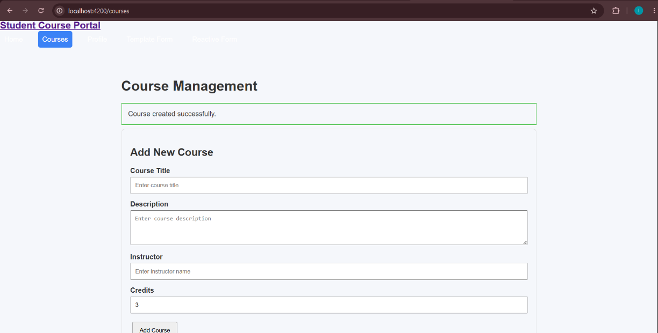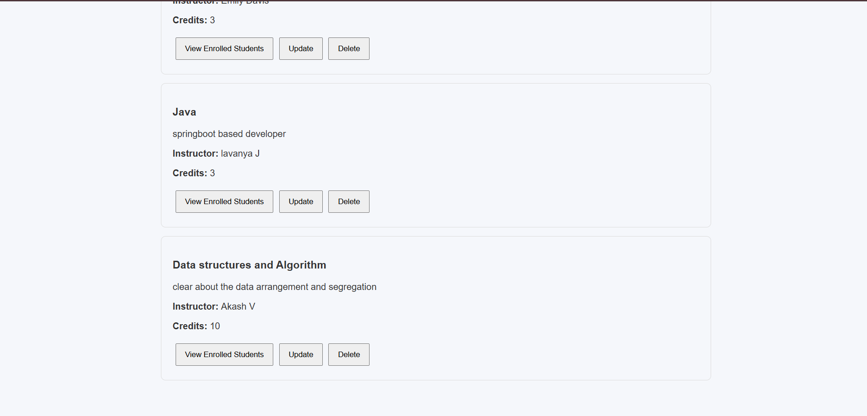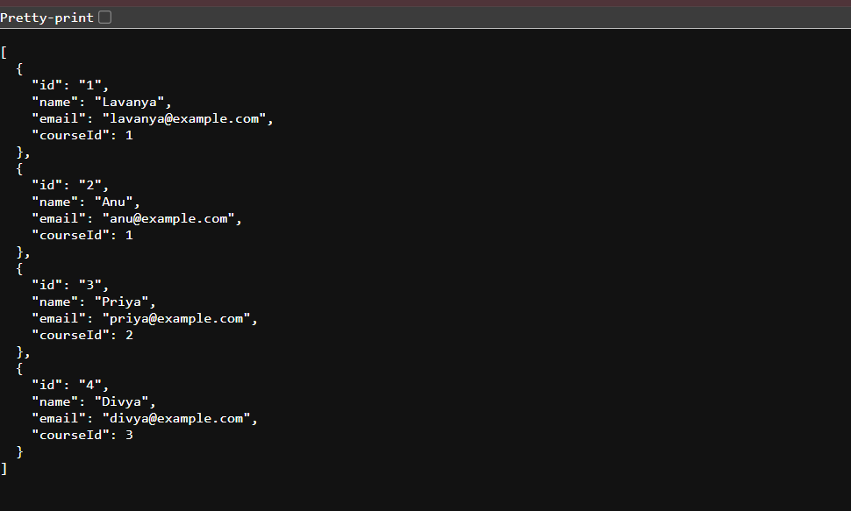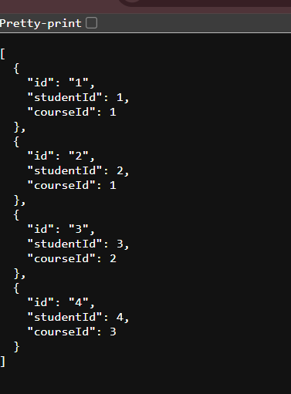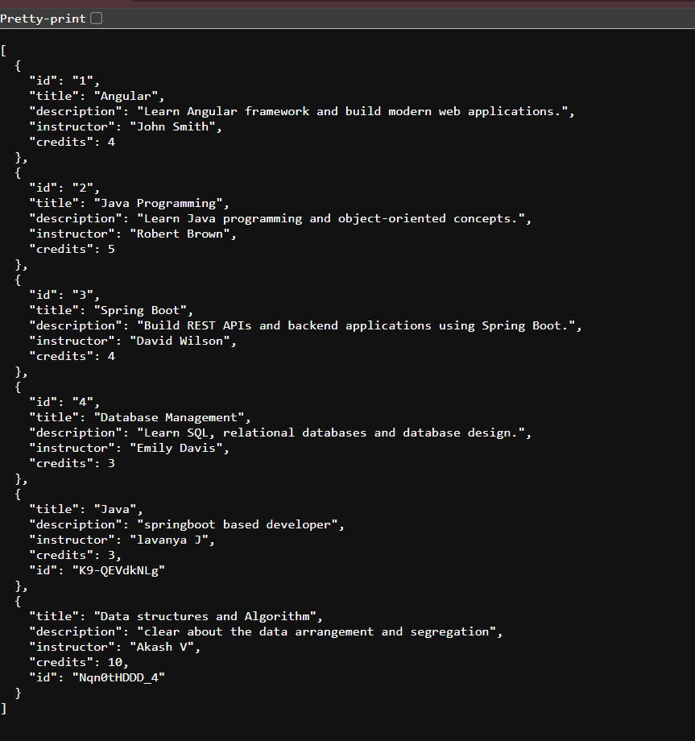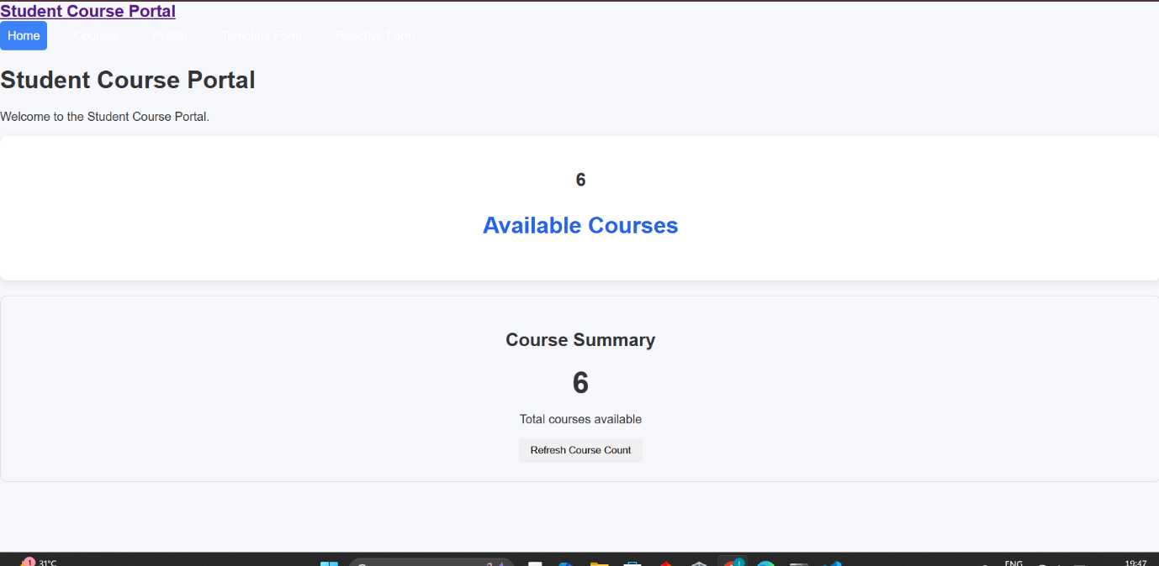

TERMINAL:
